**FLOATING BAMBOO HOUSES FOR CLIMATE REFUGEES**

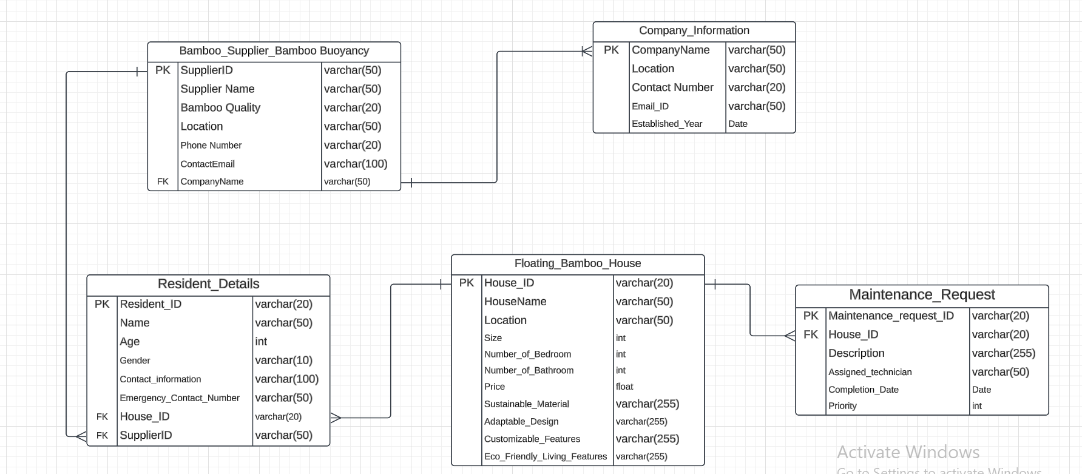

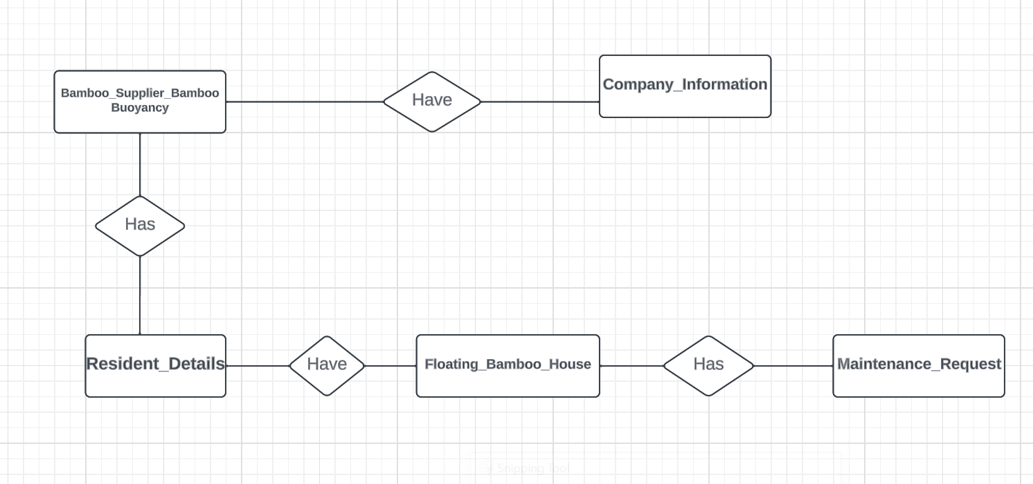

**Relationship:**

Bamboo_Supplier_Bamboo Buoyancy Entity are depend on Company_Information in a one to many relationship

Bamboo_Supplier_Bamboo Buoyancy Entity are also depend on Resident_Details in one to many relationship

Floating_Bamboo_House Entity are depend on Maintenance_Request and Resident_Details

Floating_Bamboo_House Entity are depend on Maintenance_Request in a one to many relationship and Floating_Bamboo_House Entity are depend on Resident_Details in a one to many relationship